Vendor Documents Access Portal

Description: Vendor Access Document is a KOHLS portal facilitating the vendors to drop their documents on the portal from where they will be moved to the Cloud, and can be accessed by the defined authorities of the same vendors.

Objective: Determining the requirements for the completion of this project.

Analysis: While gathering information about the requirements, I concluded that this could be done using below mentioned technologies:

Cloud Provider: Google

HTML, CSS, JavaScript, Java

Tool: Eclipse

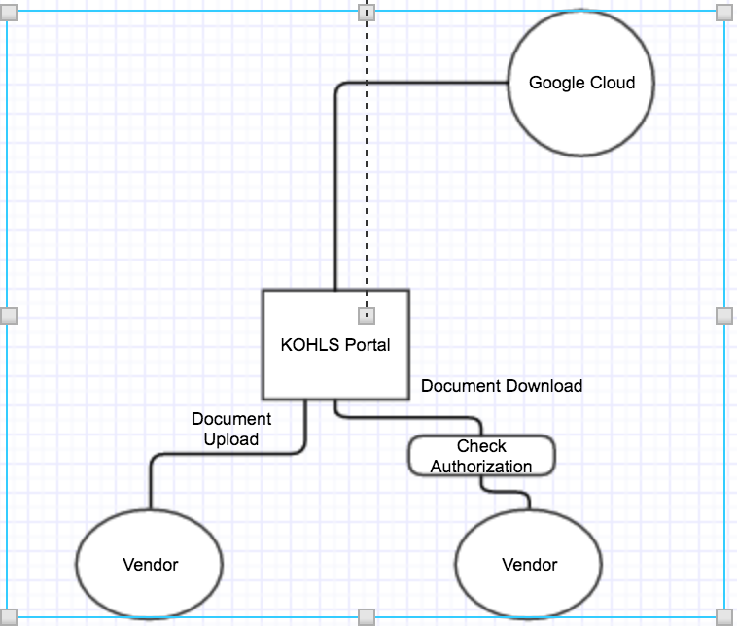

Architectural Block Diagram

Given By: To:

Yash Bansal Sanjeev Mishra

TKMAJDT